NATIONAL SCHOOL OF SCIENCES

Lainchour, Kathmandu



**A HTML PROJECT**

|  |  |
| --- | --- |
| **Submitted by:** | **Submitted to:** |
| Name: DidhitI Maharjan  Class:11  Sec:C2  Roll no.:527 | Ranoj Bhatta  Department of Computer Science |

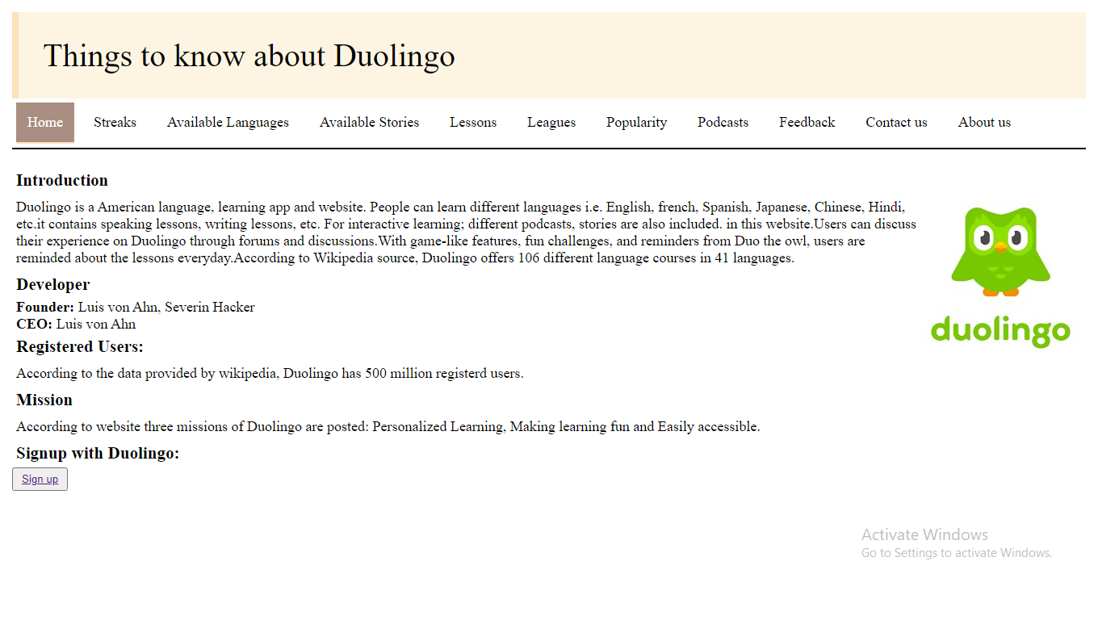

<title>home</title>

<link rel="stylesheet" href="style.css" >

</head>

<body>

<div class="top">

Things to know about Duolingo

</div>

<ul>

<li><a href="home.html" class="active">Home</a></li>

<li><a href="streak.html">Streaks</a></li>

<li><a href="language.html">Available Languages</a></li>

<li><a href="stories.html">Available Stories</a></li>

<li><a href="lessons.html">Lessons</a></li>

<li><a href="leagues.html">Leagues</a></li>

<li><a href="popular.html">Popularity</a></li>

<li><a href="podcasts.html">Podcasts</a></li>

<li><a href="feedback.html">Feedback</a></li>

<li><a href="contact.html">Contact us</a></li>

<li><a href="about.html">About us</a></li>

</ul><br>

<H3>Introduction</h3>

<p><img src="duolingo2.jpg" float="right">

Duolingo is a American language, learning app and website.

People can learn different languages i.e. English, french, Spanish, Japanese, Chinese, Hindi, etc.it contains speaking lessons, writing lessons, etc.

For interactive learning; different podcasts, stories are also included. in this website.Users can discuss their experience on Duolingo through forums and discussions.With game-like features, fun challenges, and reminders from Duo the owl, users are reminded about the lessons everyday.According to Wikipedia source, Duolingo offers 106 different language courses in 41 languages.</p>

<h3>Developer</h3>

<b>Founder:</b>Luis von Ahn, Severin Hacker<br>

<b>CEO:</b>Luis von Ahn<br>

<h3>Registered Users:</h3>

<p>According to the data provided by wikipedia, Duolingo has 500 million registerd users.</p>

<h3>Mission</h3>

<p>According to website three missions of Duolingo are posted: Personalized Learning, Making learning fun and Easily accessible.</p>

<h3>Signup with Duolingo:</h3><button><a href="https://www.duolingo.com/">Sign up</a></button>

</body>

</html>

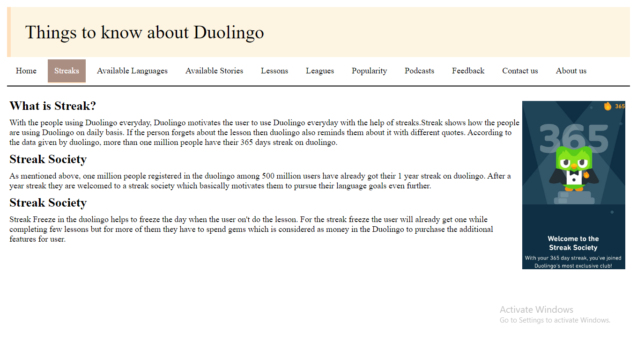

<!DOCTYPE html>

<html>

<head>

<title>home</title>

<link rel="stylesheet" href="style.css" >

</head>

<body>

<div class="top">Things to know about Duolingo

</div>

<ul>

<li><a href="home.html">Home</a></li>

<li><a href="streak.html" class="active">Streaks</a></li>

<li><a href="language.html">Available Languages</a></li>

<li><a href="stories.html">Available Stories</a></li>

<li><a href="lessons.html">Lessons</a></li>

<li><a href="leagues.html">Leagues</a></li>

<li><a href="popular.html">Popularity</a></li>

<li><a href="podcasts.html">Podcasts</a></li>

<li><a href="feedback.html">Feedback</a></li>

<li><a href="contact.html">Contact us</a></li>

<li><a href="about.html">About us</a></li>

</ul><br>

<h2>What is Streak?<img src="owl.jpg" float="right" height=370 width=230 ></h2>

<p>With the people using Duolingo everyday, Duolingo motivates the user to use Duolingo everyday with the help of streaks.Streak shows how the people are using Duolingo on daily basis. If the person forgets about the lesson then duolingo also reminds them about it with different quotes.

According to the data given by duolingo, more than one million people have their 365 days streak on duolingo.</p>

<h2>Streak Society</h2>

<p> As mentioned above, one million people registered in the duolingo among 500 million users have already got their 1 year streak on duolingo. After a year streak they are welcomed to a streak society which basically motivates them to pursue their language goals even further.</p>

<h2>Streak Society</h2>

<p>Streak Freeze in the duolingo helps to freeze the day when the user on't do the lesson. For the streak freeze the user will already get one while completing few lessons but for more of them they have to spend gems which is considered as money in the Duolingo to purchase the additional features for user.</p>

</body>

</html>

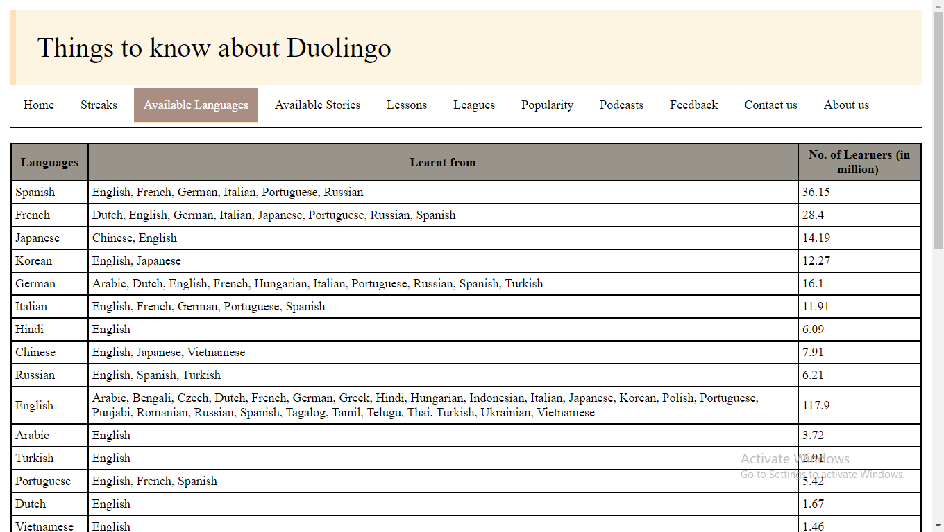 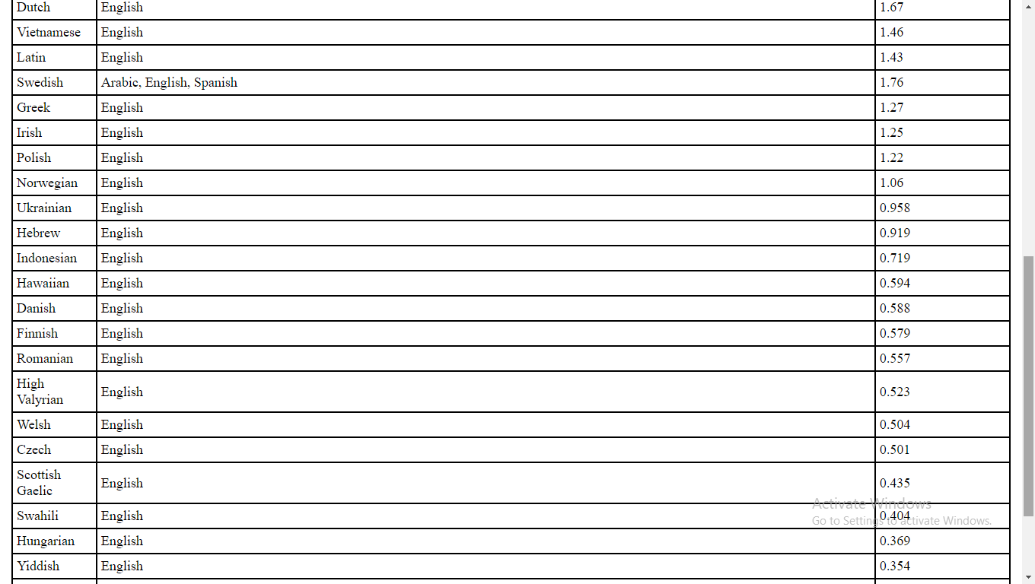 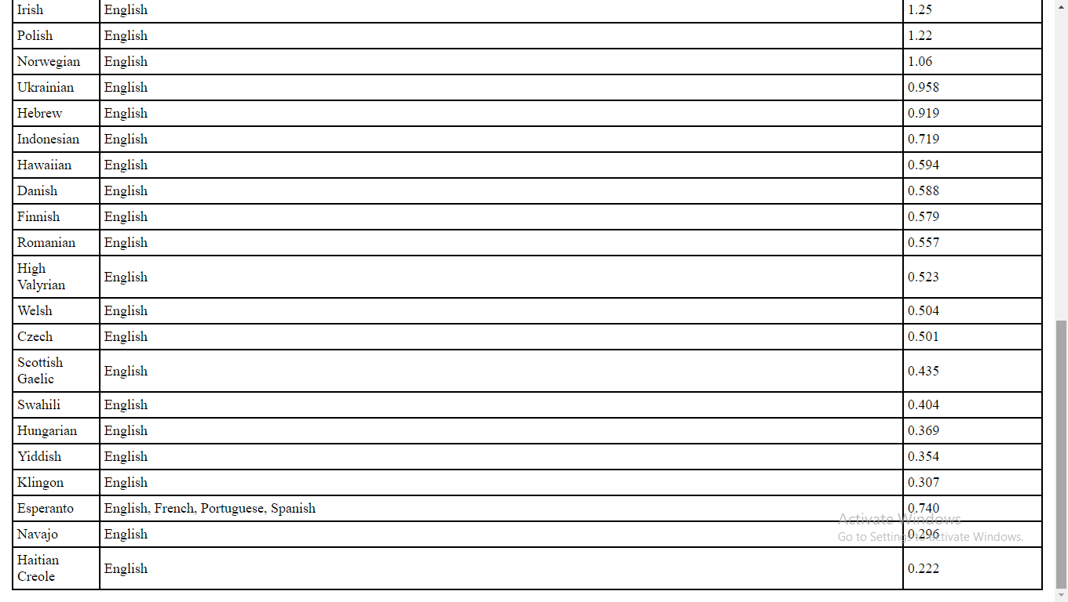

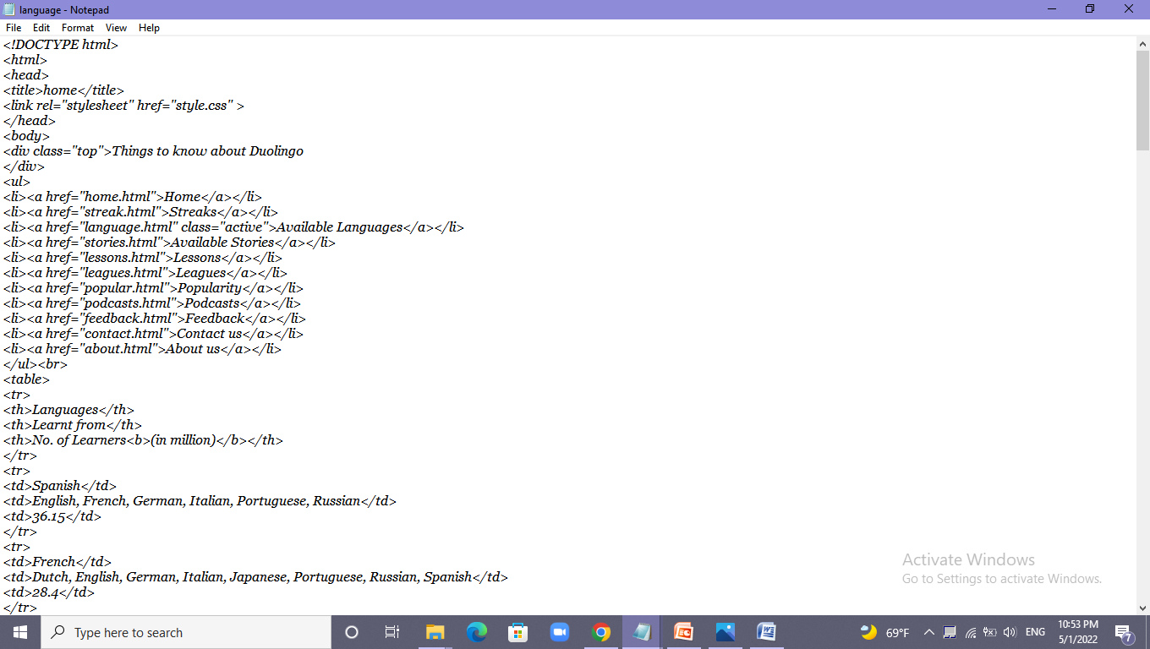

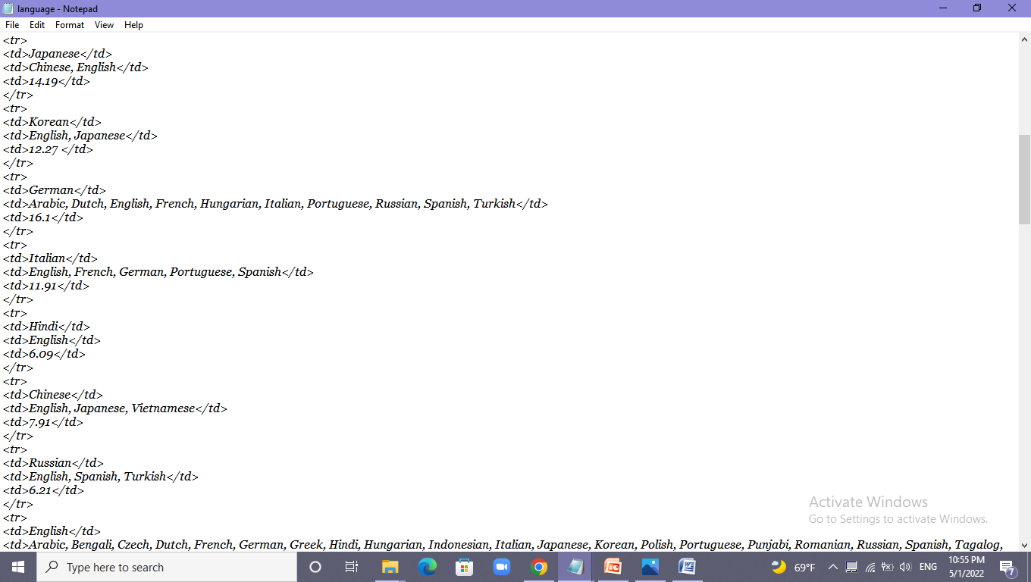

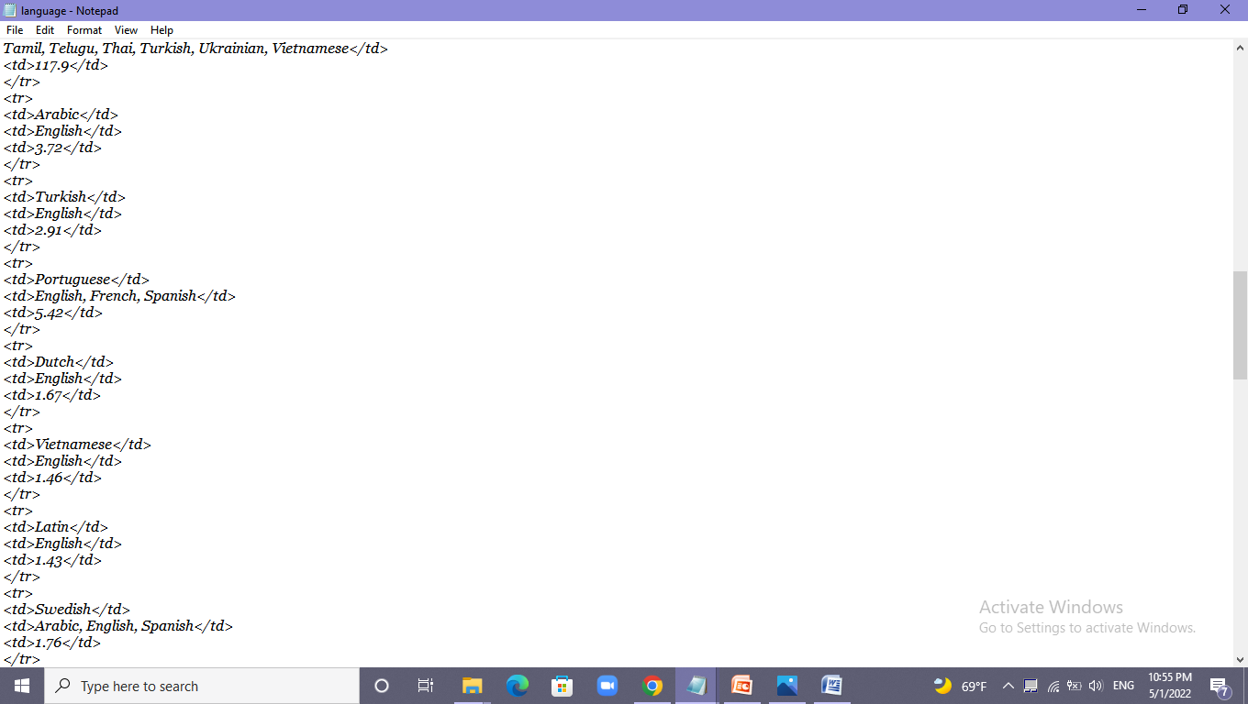

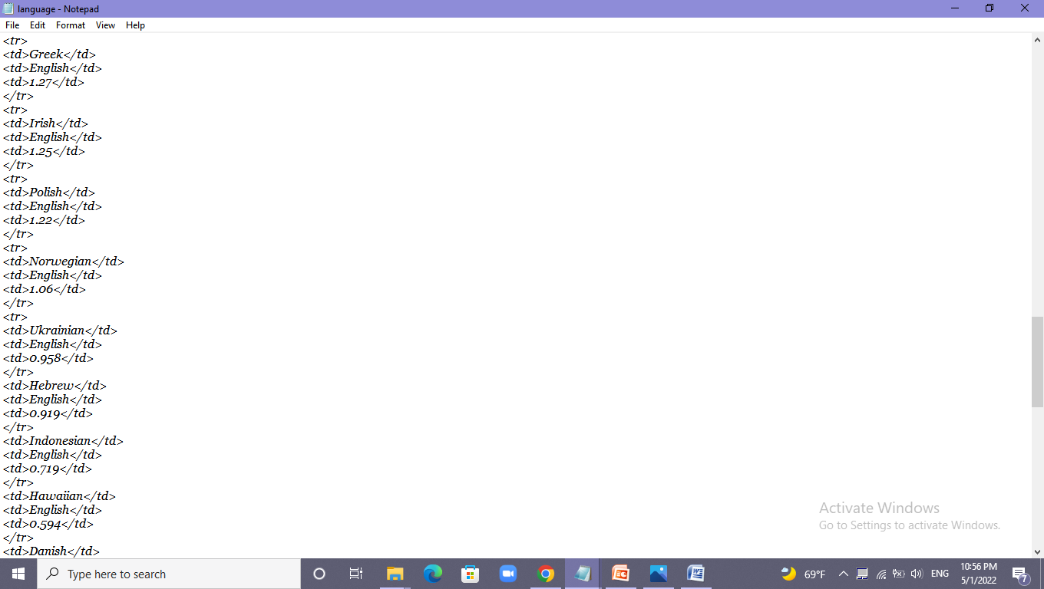 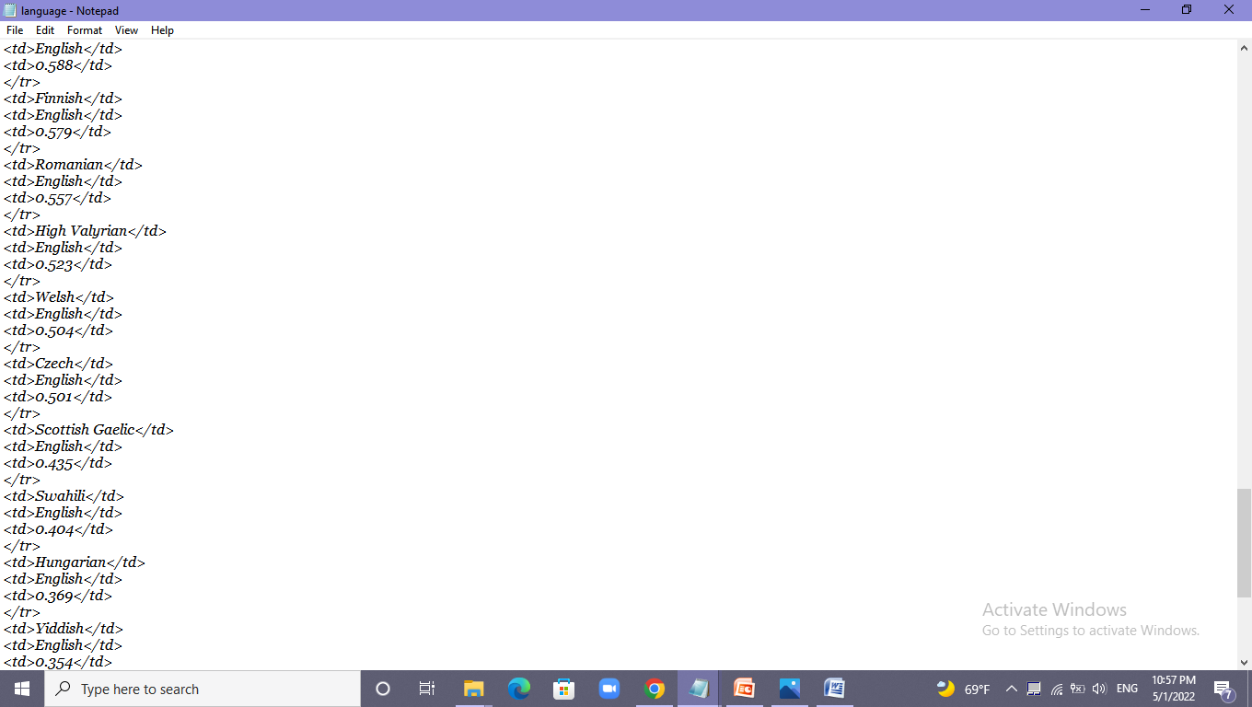

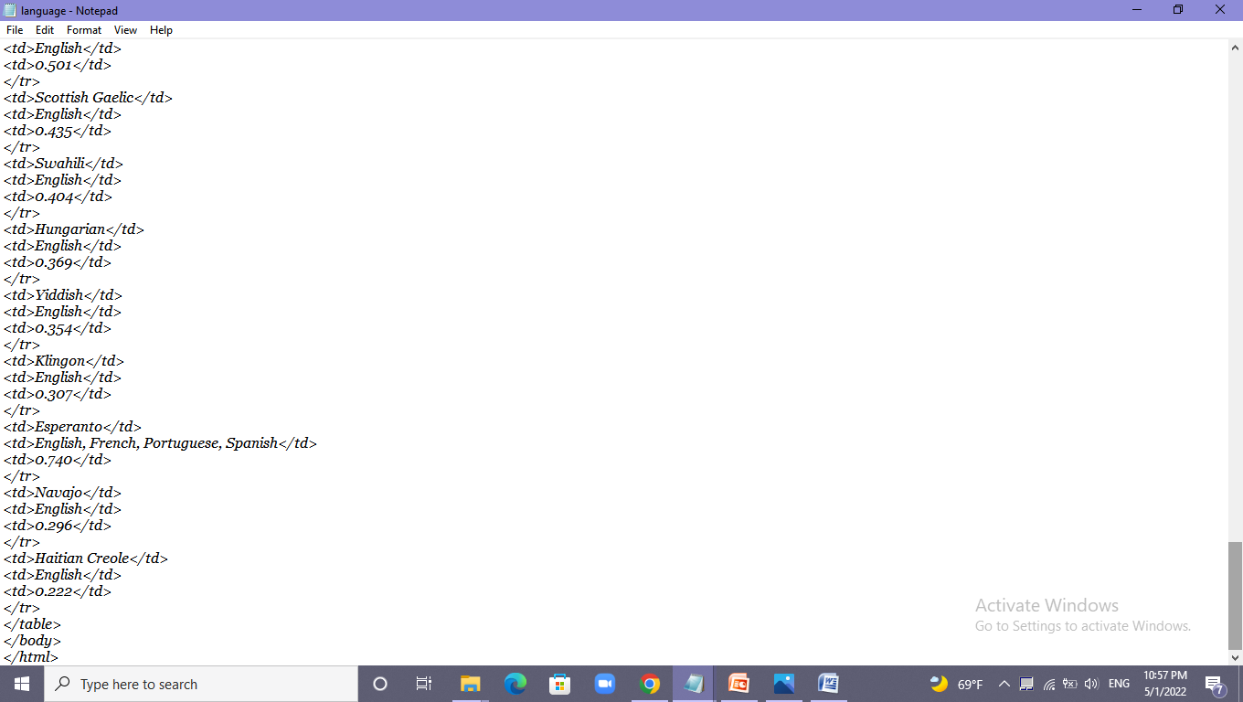

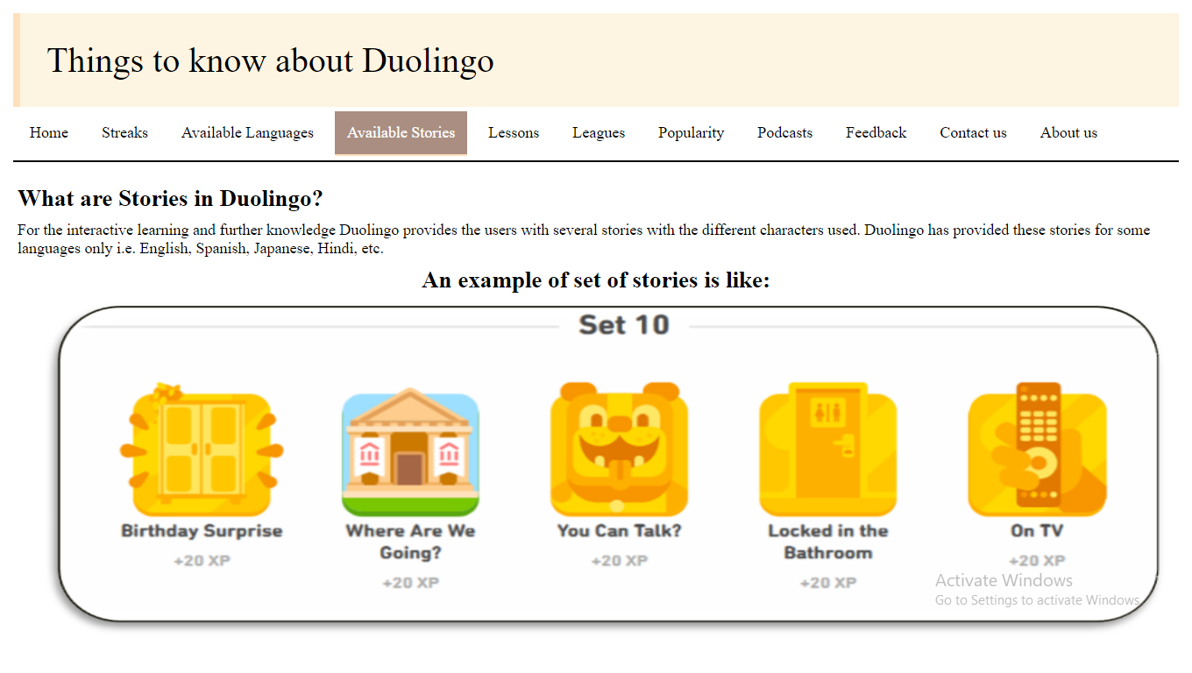

<!DOCTYPE html>

<html>

<head>

<title>home</title>

<link rel="stylesheet" href="style.css" >

</head>

<body>

<div class="top">Things to know about Duolingo

</div>

<ul>

<li><a href="home.html">Home</a></li>

<li><a href="streak.html">Streaks</a></li>

<li><a href="language.html">Available Languages</a></li>

<li><a href="stories.html" class="active">Available Stories</a></li>

<li><a href="lessons.html">Lessons</a></li>

<li><a href="leagues.html">Leagues</a></li>

<li><a href="popular.html">Popularity</a></li>

<li><a href="podcasts.html">Podcasts</a></li>

<li><a href="feedback.html">Feedback</a></li>

<li><a href="contact.html">Contact us</a></li>

<li><a href="about.html">About us</a></li>

</ul><br>

<h2>What are Stories in Duolingo?</h2>

<p>For the interactive learning and further knowledge Duolingo provides the users with several stories with the different characters used.

Duolingo has provided these stories for some languages only i.e. English, Spanish, Japanese, Hindi, etc.</p>

<h2 align="center">An example of set of stories is like:<img src="set.png" width=1300 height=400></h2>

</body>

</html>

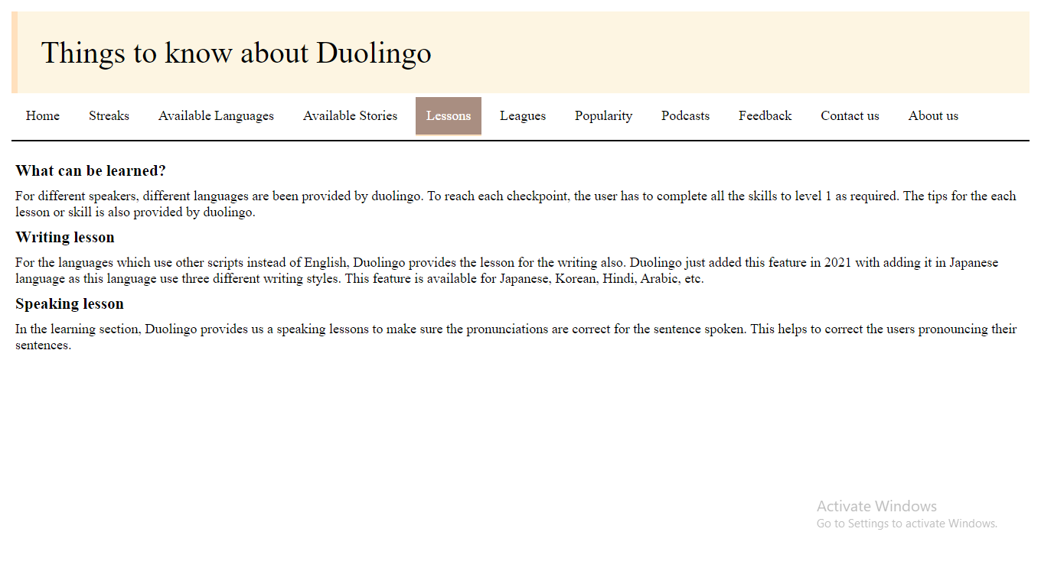

<!DOCTYPE html>

<html>

<head>

<title>home</title>

<link rel="stylesheet" href="style.css" >

</head>

<body>

<div class="top">Things to know about Duolingo

</div>

<ul>

<li><a href="home.html">Home</a></li>

<li><a href="streak.html">Streaks</a></li>

<li><a href="language.html">Available Languages</a></li>

<li><a href="stories.html">Available Stories</a></li>

<li><a href="lessons.html" class="active">Lessons</a></li>

<li><a href="leagues.html">Leagues</a></li>

<li><a href="popular.html">Popularity</a></li>

<li><a href="podcasts.html">Podcasts</a></li>

<li><a href="feedback.html">Feedback</a></li>

<li><a href="contact.html">Contact us</a></li>

<li><a href="about.html">About us</a></li>

</ul><br>

<h3>What can be learned?</h3>

<p>For different speakers, different languages are been provided by duolingo.

To reach each checkpoint, the user has to complete all the skills to level 1 as required.

The tips for the each lesson or skill is also provided by duolingo.</p>

<h3>Writing lesson</h3>

<p>For the languages which use other scripts instead of English, Duolingo provides the lesson for the writing also.

Duolingo just added this feature in 2021 with adding it in Japanese language as this language use three different writing styles.

This feature is available for Japanese, Korean, Hindi, Arabic, etc.</p>

<h3>Speaking lesson</h3>

<p>In the learning section, Duolingo provides us a speaking lessons to make sure the pronunciations are correct for the sentence spoken.

This helps to correct the users pronouncing their sentences.</p>

</body>

</html>

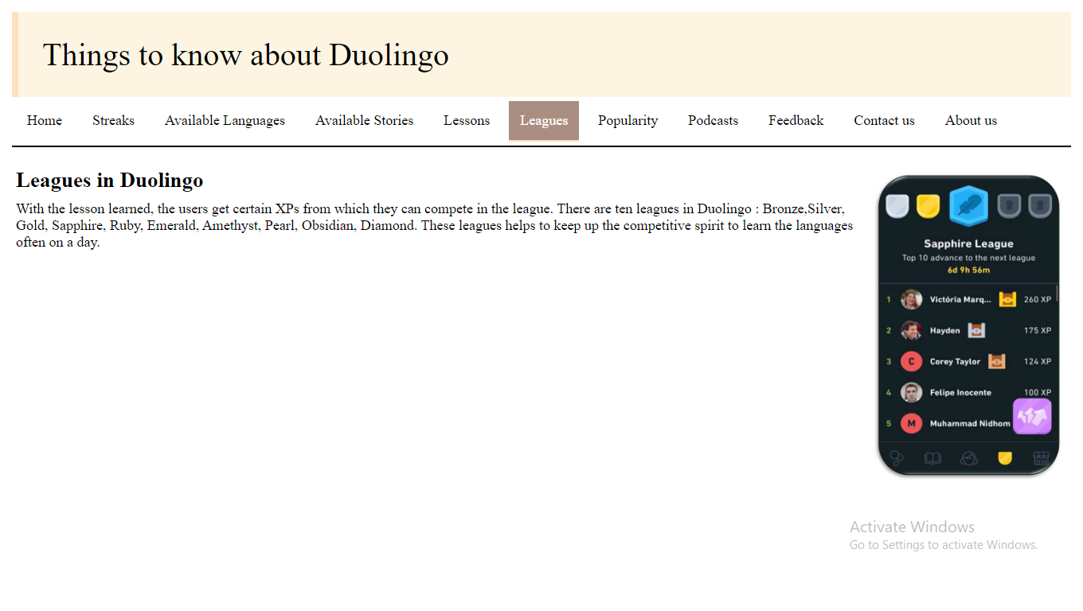 <!DOCTYPE html>

<html>

<head>

<title>home</title>

<link rel="stylesheet" href="style.css" >

</head>

<body>

<div class="top">Things to know about Duolingo

</div>

<ul>

<li><a href="home.html">Home</a></li>

<li><a href="streak.html">Streaks</a></li>

<li><a href="language.html">Available Languages</a></li>

<li><a href="stories.html">Available Stories</a></li>

<li><a href="lessons.html">Lessons</a></li>

<li><a href="leagues.html" class="active">Leagues</a></li>

<li><a href="popular.html">Popularity</a></li>

<li><a href="podcasts.html">Podcasts</a></li>

<li><a href="feedback.html">Feedback</a></li>

<li><a href="contact.html">Contact us</a></li>

<li><a href="about.html">About us</a></li>

</ul><br>

<h2><img src="lee.jpg" height=400 width=250>Leagues in Duolingo</h2>

<p>With the lesson learned, the users get certain XPs from which they can compete in the league.

There are ten leagues in Duolingo : Bronze,Silver, Gold, Sapphire, Ruby, Emerald, Amethyst, Pearl, Obsidian, Diamond.

These leagues helps to keep up the competitive spirit to learn the languages often on a day.</p>

</body>

</html>

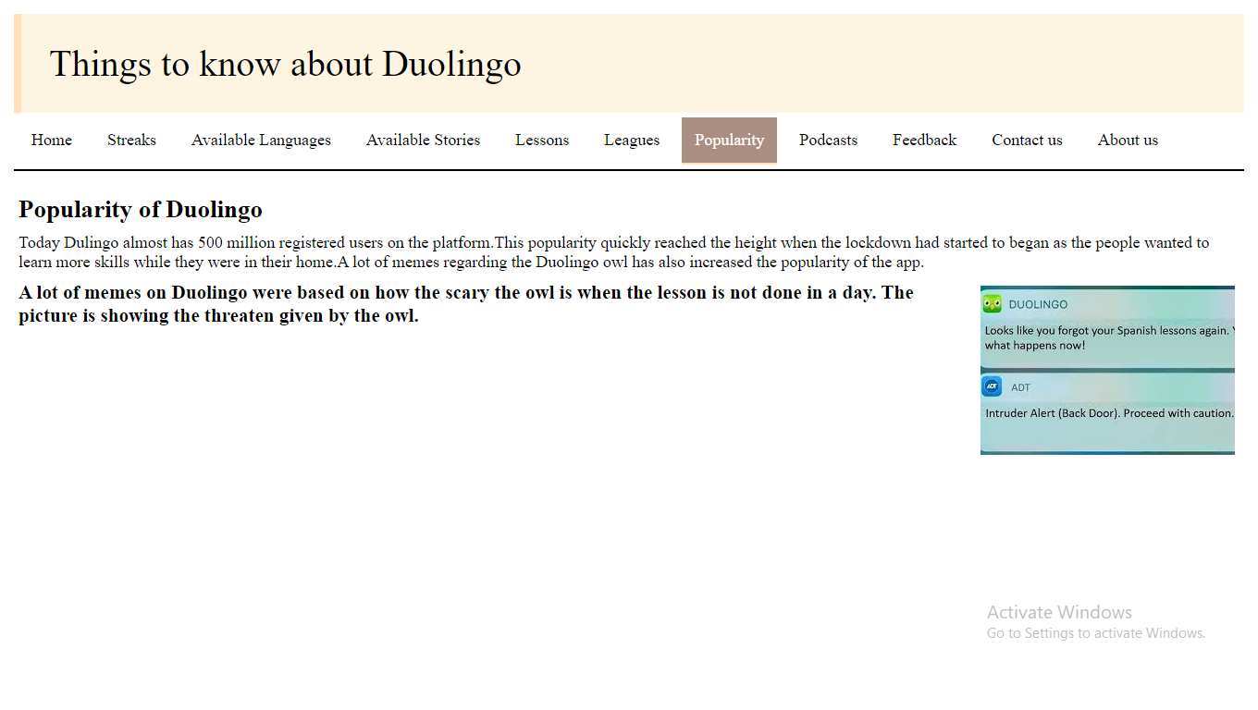

<!DOCTYPE html>

<html>

<head>

<title>home</title>

<link rel="stylesheet" href="style.css" >

</head>

<body>

<div class="top">Things to know about Duolingo

</div>

<ul>

<li><a href="home.html">Home</a></li>

<li><a href="streak.html">Streaks</a></li>

<li><a href="language.html">Available Languages</a></li>

<li><a href="stories.html">Available Stories</a></li>

<li><a href="lessons.html">Lessons</a></li>

<li><a href="leagues.html">Leagues</a></li>

<li><a href="popular.html" class="active">Popularity</a></li>

<li><a href="podcasts.html">Podcasts</a></li>

<li><a href="feedback.html">Feedback</a></li>

<li><a href="contact.html">Contact us</a></li>

<li><a href="about.html">About us</a></li>

</ul><br>

<h2>Popularity of Duolingo</h2>

<p>Today Dulingo almost has 500 million registered users on the platform.This popularity quickly reached the height when the lockdown had started to began as the people wanted to learn more skills while they were in their home.A lot of memes regarding the Duolingo owl has also increased the popularity of the app.</p>

<h3><img src="meme.jpg"> A lot of memes on Duolingo were based on how the scary the owl is when the lesson is not done in a day. The picture is showing the threaten given by the owl.</h3>

</body>

</html>

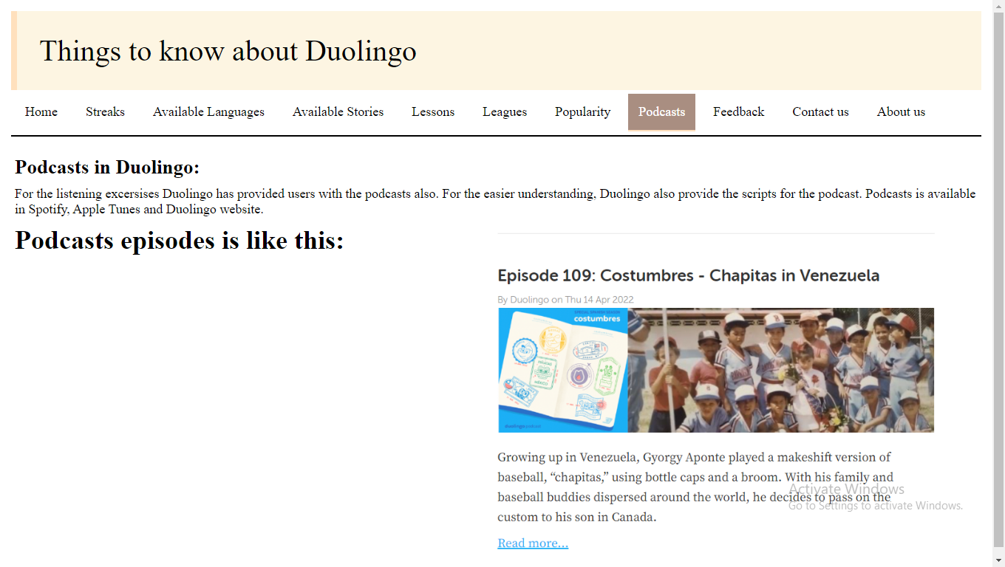

<!DOCTYPE html>

<html>

<head>

<title>home</title>

<link rel="stylesheet" href="style.css" >

</head>

<body>

<div class="top">Things to know about Duolingo

</div>

<ul>

<li><a href="home.html">Home</a></li>

<li><a href="streak.html">Streaks</a></li>

<li><a href="language.html">Available Languages</a></li>

<li><a href="stories.html">Available Stories</a></li>

<li><a href="lessons.html">Lessons</a></li>

<li><a href="leagues.html">Leagues</a></li>

<li><a href="popular.html">Popularity</a></li>

<li><a href="podcasts.html" class="active">Podcasts</a></li>

<li><a href="feedback.html">Feedback</a></li>

<li><a href="contact.html">Contact us</a></li>

<li><a href="about.html">About us</a></li>

</ul><br>

<h2>Podcasts in Duolingo:</h2>

<p>For the listening excersises Duolingo has provided users with the podcasts also.

For the easier understanding, Duolingo also provide the scripts for the podcast.

Podcasts is available in Spotify, Apple Tunes and Duolingo website.</p>

<h1><img src="pod.png" height=470>Podcasts episodes is like this:</h1>

</body>

</html>

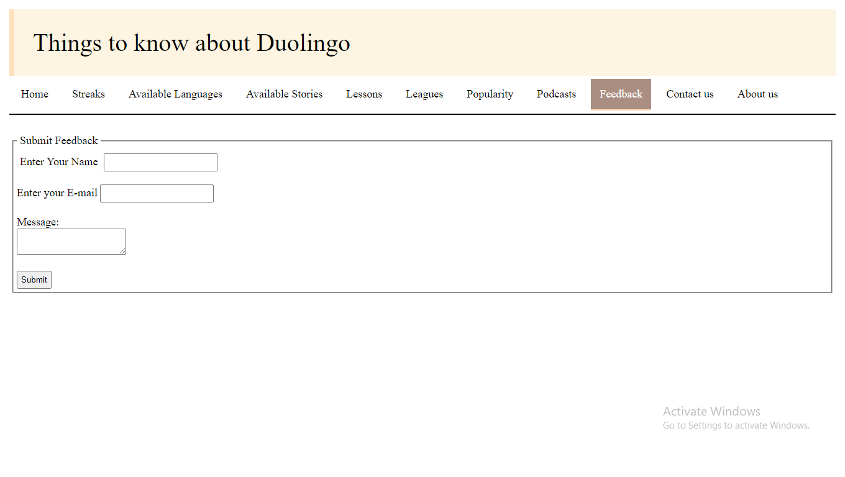

<!DOCTYPE html>

<html>

<head>

<title>home</title>

<link rel="stylesheet" href="style.css" >

</head>

<body>

<div class="top">Things to know about Duolingo

</div>

<ul>

<li><a href="home.html">Home</a></li>

<li><a href="streak.html">Streaks</a></li>

<li><a href="language.html">Available Languages</a></li>

<li><a href="stories.html">Available Stories</a></li>

<li><a href="lessons.html">Lessons</a></li>

<li><a href="leagues.html">Leagues</a></li>

<li><a href="popular.html">Popularity</a></li>

<li><a href="podcasts.html">Podcasts</a></li>

<li><a href="feedback.html" class="active">Feedback</a></li>

<li><a href="contact.html">Contact us</a></li>

<li><a href="about.html">About us</a></li>

</ul><br>

<form>

<fieldset>

<legend>Submit Feedback</legend>

<label for="Name"> Enter Your Name</label>

<input type="text" name="fname" id="Name"><br><br>

Enter your E-mail

<input type="email" name="email"><br><br>

Message: <br><textarea type="mess"></textarea><br><br>

<button>Submit</button>

</fieldset>

</form>

</body>

</html>

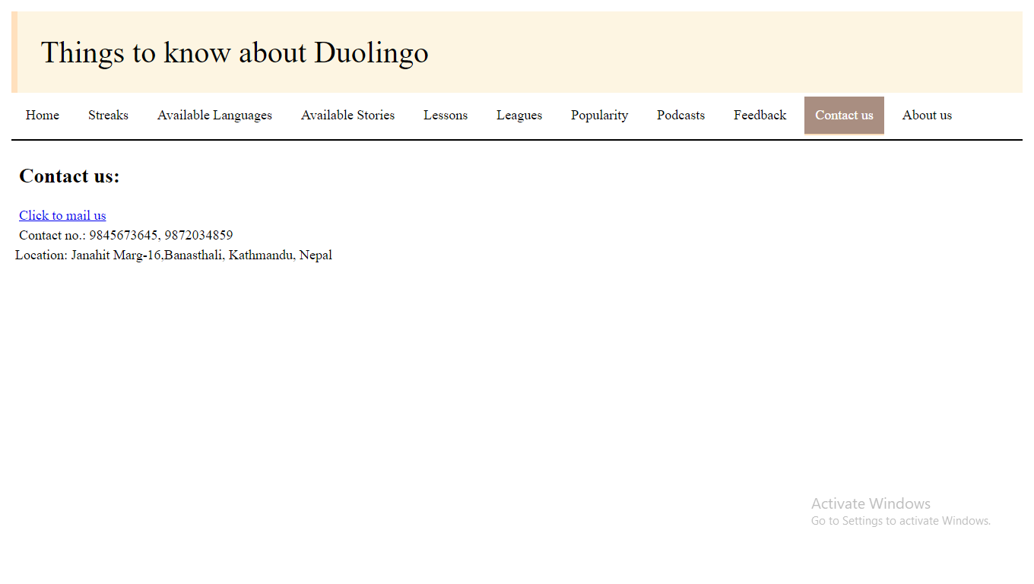

<!DOCTYPE html>

<html>

<head>

<title>home</title>

<link rel="stylesheet" href="style.css" >

</head>

<body>

<div class="top">Things to know about Duolingo

</div>

<ul>

<li><a href="home.html">Home</a></li>

<li><a href="streak.html">Streaks</a></li>

<li><a href="language.html">Available Languages</a></li>

<li><a href="stories.html">Available Stories</a></li>

<li><a href="lessons.html">Lessons</a></li>

<li><a href="leagues.html">Leagues</a></li>

<li><a href="popular.html">Popularity</a></li>

<li><a href="podcasts.html">Podcasts</a></li>

<li><a href="feedback.html">Feedback</a></li>

<li><a href="contact.html" class="active">Contact us</a></li>

<li><a href="about.html">About us</a></li>

</ul><br>

<div class="cont">

<h2>Contact us:</h2><br>

<a href="mailto: didhitimaharjan10@gmail.com">Click to mail us</a><br>

<p>Contact no.: 9845673645, 9872034859</p>

Location:

Janahit Marg-16,Banasthali, Kathmandu, Nepal

</body>

</html>

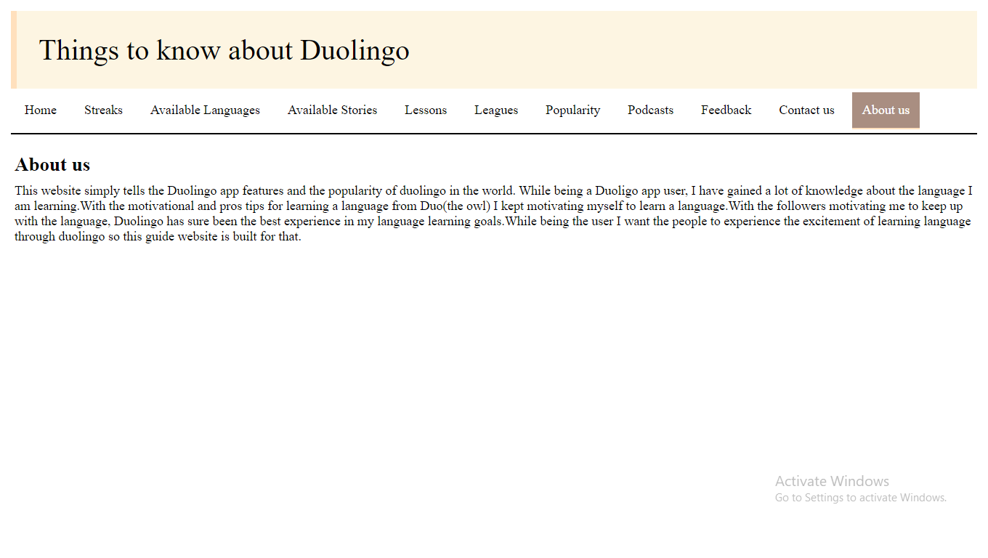

<!DOCTYPE html>

<html>

<head>

<title>home</title>

<link rel="stylesheet" href="style.css" >

</head>

<body>

<div class="top">Things to know about Duolingo

</div>

<ul>

<li><a href="home.html">Home</a></li>

<li><a href="streak.html">Streaks</a></li>

<li><a href="language.html">Available Languages</a></li>

<li><a href="stories.html">Available Stories</a></li>

<li><a href="lessons.html">Lessons</a></li>

<li><a href="leagues.html">Leagues</a></li>

<li><a href="popular.html">Popularity</a></li>

<li><a href="podcasts.html">Podcasts</a></li>

<li><a href="feedback.html">Feedback</a></li>

<li><a href="contact.html">Contact us</a></li>

<li><a href="about.html" class="active">About us</a></li>

</ul><br>

<h2> About us</h2>

<p> This website simply tells the Duolingo app features and the popularity of duolingo in the world. While being a Duoligo app user, I have gained a lot of knowledge about the language I am learning.With the motivational and pros tips for learning a language from Duo(the owl) I kept motivating myself to learn a language.With the followers motivating me to keep up with the language, Duolingo has sure been the best experience in my language learning goals.While being the user I want the people to experience the excitement of learning language through duolingo so this guide website is built for that.</p>

</body>

</html>

**CSS Code:**

*{

margin: 0px;

box-sizing: border-box;

padding: 5px;

}

body{

font-size: large;

font-family: none;

padding: 10px;

background: white;

}

ul {

list-style-type: none;

margin: 0;

padding: 0;

overflow: hidden;

background-color: white;

border-bottom: 2px solid black;

}

li {

float: left;

}

li a {

display: block;

color: black;

text-align: center;

padding: 14px 14px;

text-decoration: none;

font-size: 18px;

}

li a:hover {

background-color: #a98e81;

color:white;

border-bottom: 2px solid #ffe0bd ;

}

.active{

background-color: #a98e81;

color:white;

border-bottom: 2px solid #ffe0bd ;

}

.top{

background-color: #fdf5e2;

padding:30px;

font-size:40px;

border-left: 8px solid #ffe0bd;

}

#sign{

border: 10px solid gray;

padding: 14px 14px;

margin:0;

background-color:#ffe0bd;

border-radius: 5%;

float: right;

}

img{

float:right;

}

table,th ,td{

border: 2px solid black;

border-collapse: collapse;

}

th{

background-color: #98948c;

}